**🔮⏳ Hopping Out of Time 🐸🌟**

**Elise Chevalier – UCID: 30095840**

**Sara Wahby – UCID: 30080345**

*“Lost in magical time”*  
  
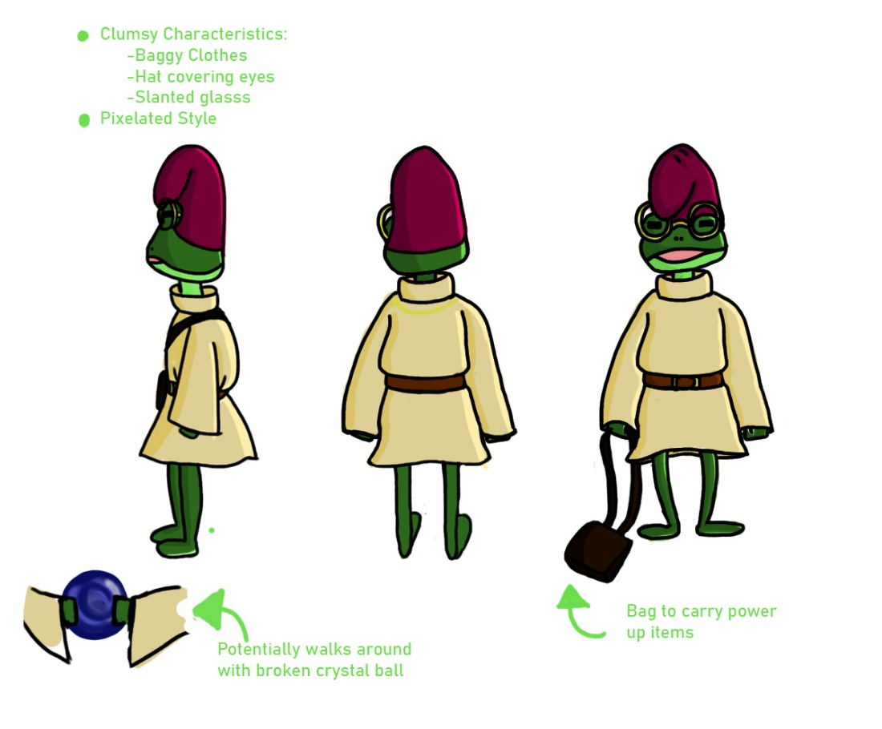

# 1 Game Analysis

This is a puzzle/platformer-style game that requires skillful navigation (platforming). The game entails a Whimsy mystical theme (Silly Wizards) set in a 2D environment. The goal of the game is to navigate to the top of one large wizard tower level filled with wacky and unconventional out-of-control experiments. The experiments will challenge the player’s journey to the top of the tower, which they must reach before time runs out.

## 1.1 Game Concept

A clumsy little wizard’s experiments go wrong causing a magical artifact to be smashed, and the wizard is sent back in time and space to the bottom of their tower. The nature of the artifact causes time loops, the wizard must race against time climbing their maze-like tower, full of wacky experiments and magical effects. Players will be able to collect powers along the way to help the wizard navigate back to the top, to stop the artifact from breaking before the time loop sends the wizard back to the bottom once again.

## 1.2 Game Goals

* Race against Time
* Silly / Whimsical natured (styled)
* Navigation mixed with puzzle-solving
* Semi-sandbox approach to progression, navigation ‘puzzles’ can be solved with creative use of different powers

## 1.3 Game Information

2D Pixel Art - Puzzle Platformer

## 1.5 Target Audience

People with previous experience in gaming, or people with awareness of the conventional platformer-style game. Ideally, the game will have a difficulty curve like that of Mario games. So, the early stage of gameplay will be straightforward with simple/conventional mechanics. However, as the player progresses, the gameplay adds layers of unconventional navigation puzzles and paths that ramp up the game’s complexity.

## 1.6 Competitor’s Analysis

* The game is platformer with a race against time aspect. With each loop iteration, the player will have learned the position of items that grant various powers, which ones to go for first to navigate the levels more effectively.
* The looping nature of the game breeds experimentation of routes to take and ability usage.
* Weird and zany abilities will be tied into the theme of wacky magical wizards, this will be reflected in the level geometry and environmental effects.

# 2 Game Design

## 2.1 Expanded Game Concept

* 2D traversal and navigation, left, right, up, down, jumping
* Enhanced abilities through a collection of magical artifacts that grant powers, such as dash, short distance teleports, telekinesis, shapeshifting... etc.
* When the player obtains different magical artifacts, various magical abilities are added to their spell book / arsenal. The player can actively switch between powers to use them, and possibly chain their effects together.
* Various levels of the tower will have different themes and enchantment effects that will change the level geometry (dynamic effects such as moving platforms, certain abilities enhances or disabled)

## 2.2 Game Structure

Single vertically sprawling level, a wizard’s tower with sub-sections that hold different themes and magical effects. All in a race against time to reach the top, where the inciting incident took place.

## 2.3 Gameplay

The core gameplay centers a little wizard which the players can control to jump, glide, run, teleport, manipulate objects and states of matters.  
Navigating through various levels of a tall wizard's towers that contain various magical effects that affect traversal and gameplay.

## 2.4 Expanded Gameplay

At the beginning of the game the player finds themselves at the bottom of the tower with multiple paths available to them, they will explore these paths by moving and jumping between moving platforms (themed as bookshelves and other wizard themed objects), navigating jumping puzzles and platforming challenges to reach various rooms in the wizard’s tower.   
 These rooms will contain a multitude of magical artifacts, when collected these artifacts will grant the player (wizard) different magical powers, such as a short dash, or teleport, the ability to manipulate objects such as moving them or freezing them from the effects of gravity. These powers will aid the player to navigate the more challenging puzzles they face higher in the tower.   
 Eventually the player will run out of time, time will be reset and rewound back to the beginning. The player will have learned what content is down a certain path, how to navigate that path more effectively and hopefully be able to complete this path faster.

# 3 Game Features

## 3.1 Key Game Features

*-* Wacky wild wizard gets sent back in time through an experiment gone wrong.

Can you help the wizard navigate their out-of-control wizard’s tower and reach the zenith to prevent the wizard’s future self from causing the infernal time loop, where they find themselves stuck in.

# 4 Summary

*-* Run, jump and use magical powers granted by artifacts hidden throughout the wizard’s tower to reach the top before time runs out.

# 5 Roles

|  |  |
| --- | --- |
| *Programmer / Implementation* | *Elise* |
| *Artist* | *Sara* |
| *Sound Designer* | *Sara* |
| *Scheduler* | *Elise* |
| *Documenter* | *Elise & Sara* |
| *Quality Assurance* | *Elise & Sara* |

# 6 Rough ideas:

# Urgent Brainstorm: - Need to figure out what the magical powers are

* Obstacles that return the player lower in the player.
* Maybe checkpoints?
* Frog is an apprentice, one of the puzzles is to find pieces of the wizard’s outfit / beard to trick guards / sentries to enter restricted parts of the tower.
* One of the artifacts / powers grant more time or rewind time, but at a cost (making the game harder?)
* Need to decide through testing if time reset loses all artifacts / powers or not
* Background music gets faster as time runs out
* Timer graphic is a sandtimer ?
* Visual effect when time rewinds (large overlay of clock rewinding)
* Audio reversed when time rewinds
* Suit of armour that walks around and breaks the platforms, solution would be to freeze the movement of the suit of armour
* Pictures frame eyes follow the player (polish implementation, not needed)
* Frog face forward for idle animation ? (don’t worry about this, It’s more of “if we have time” thing)

